Submitted on time? (YES/ NO): Yes

**Task 01**: Complete the Table 01. **40 points**

**Task 02:** Attach screenshots of the simulated circuit of the experiment showing all Multimeter/ simulation readings as mentioned in the class. **30 points**

**Task -03:** Discuss your observation from this experiment in brief. **30 points**

**NOTE**: You must submit PDF of this file

Name & ID: Md. Rifat Ahmed ~ 1931725042

**Task: 01**

Table- 2.1

|  |  |  |
| --- | --- | --- |
|  | **Half Wave Rectifier**  **(Fig 2.4)** | **Full Wave Rectifier**  **(Fig 2.5)** |
| **Vout**  **(without capacitor)** | 4.34 V | 3.71 V |
| **Vout (with 0.22 µF)** | 1.51 V | 630 mV |
| **Vout (with 10 µF)** | 34.6 mV | 22.5 mV |

**Task: 02**

Attach the screenshots of the simulated circuits with i/o waveforms below:

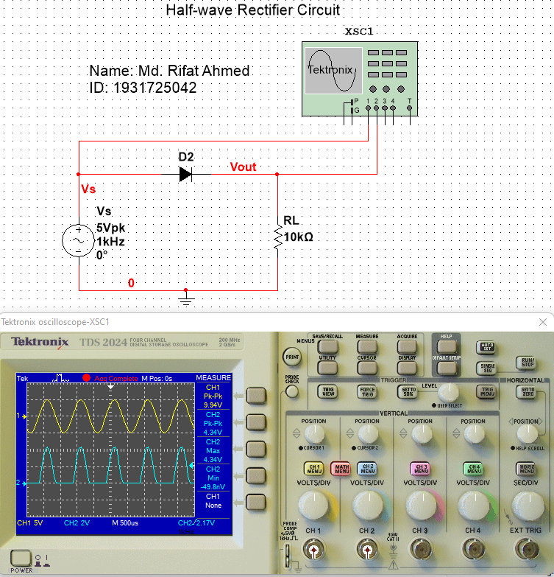

Figure – 1: Half-wave Rectifier Circuit with No Capacitor

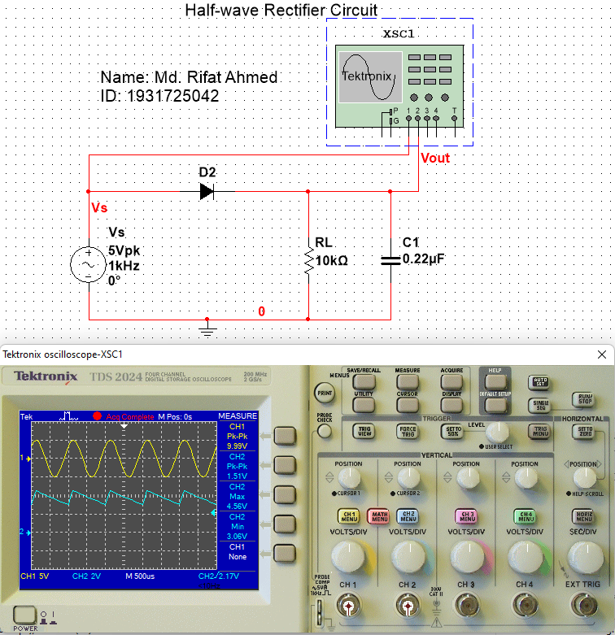

Figure – 2: Half-wave Rectifier Circuit with 0.22µF Capacitor

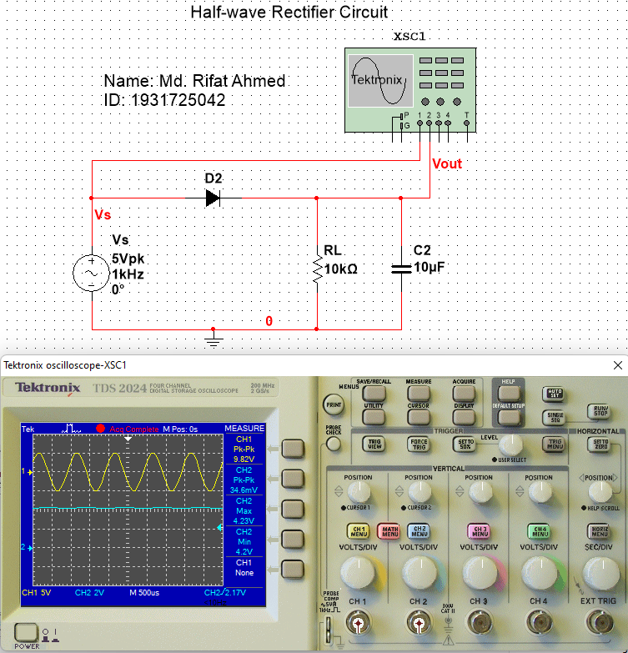

Figure – 3: Half-wave Rectifier Circuit with 10µF Capacitor

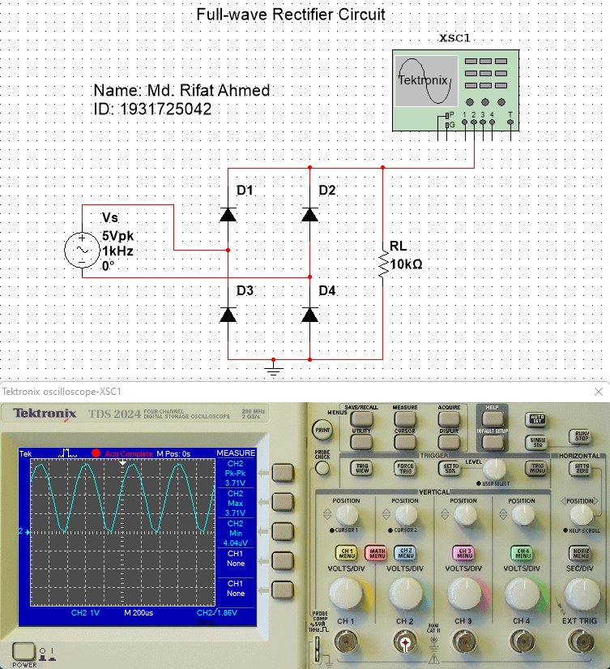

Figure – 4: Full-wave Rectifier Circuit with No Capacitor

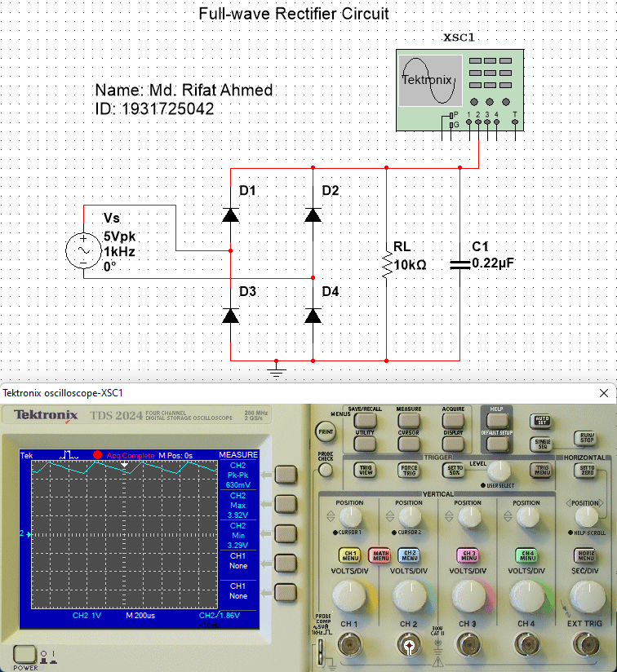

Figure – 5: Full-wave Rectifier Circuit with 0.22µF Capacitor

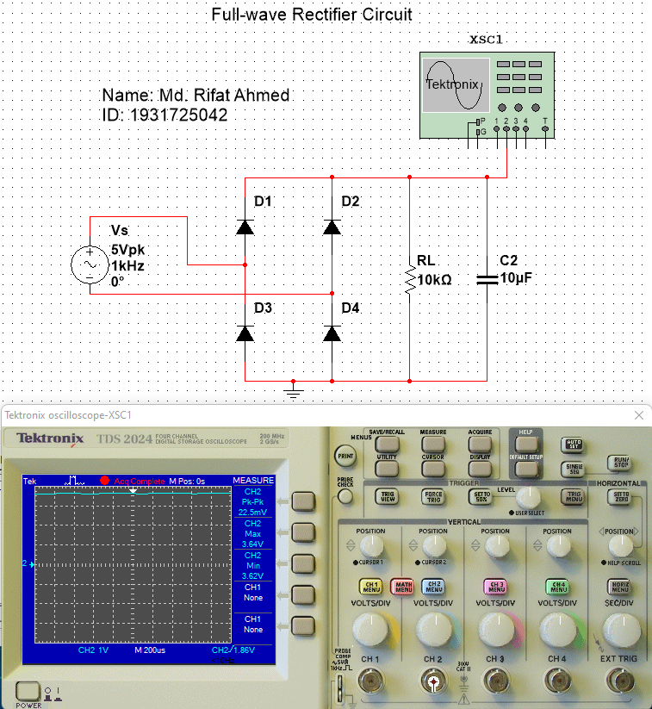

Figure – 6: Full-wave Rectifier Circuit with 10µF Capacitor

Attach only waveforms below:

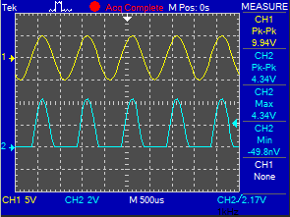 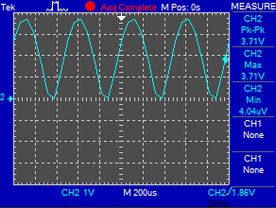

* 1. *Input-output without capacitor (Fig. 1) d) Input-output without capacitor (Fig. 4)*

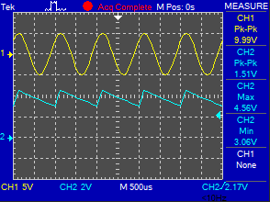 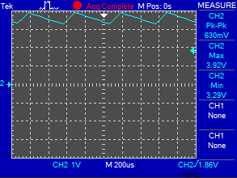

* 1. *Input-output with 0.22uF (Fig. 2)*  e) *Input-output with 0.22uF (Fig. 5)*

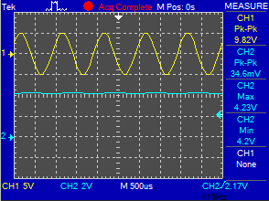 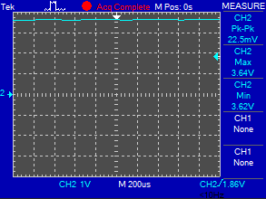

* 1. *Input-output with 10uF (Fig. 3)* f) *Input-output with 10uF (Fig. 6)*

**Task: 03**

**Observation:**

In this experiment we learnt about rectifier circuits. In a half wave rectifier circuit there’s only one diode whereas in a full wave rectifier circuit there are four diodes. In a half wave rectifier, the load receives only half of the total input power and due to the presence of ripple output voltage wave is not smooth. On the other hand, a full wave rectifier is designed using a bridge so it has both the half cycle present in the output voltage. Which is why in a full wave rectifier the output wave is smoother. And during this experiment we saw that for both half wave and full wave rectifier there was a curve when no capacitor was added to the circuit. But when we added a 0.22µF capacitor to both they started giving smaller waves and as we increased the capacitance to 10µF the lines in both the circuit got flattened for peak-to-peak voltage meaning the AC source were almost acting like an DC source. So, by adding more capacitance we can make a rectifier circuit with an AC source act like an DC source.